**For 64-bit Operating System:**

1) Run Dosbox installer.

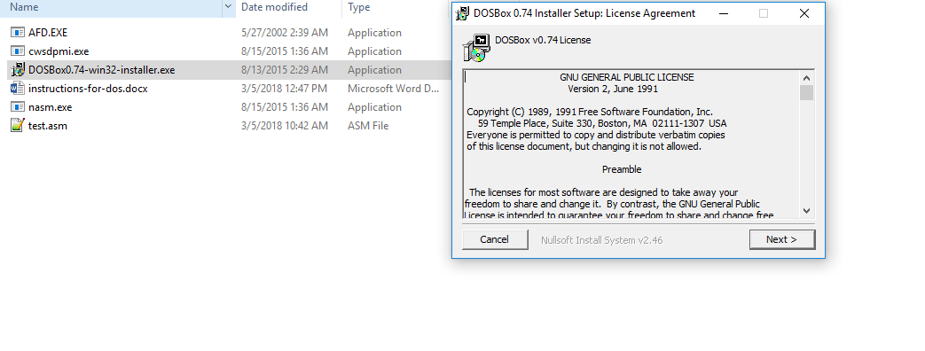

2) Create a folder “assembly" in C drive.

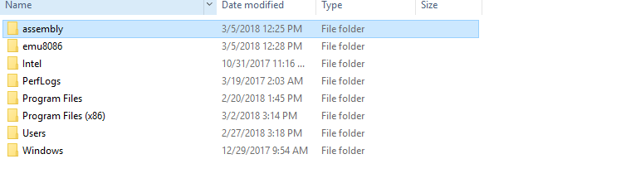

3) Copy

1. nasm.exe
2. cwsdpmi.exe
3. afd.exe

in C:/assembly.

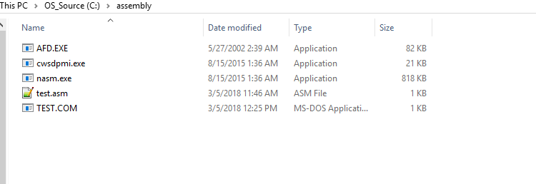

4) Open notepad file and copy sample code in it and save it as test.asm in C:/assembly.

Sample code:

__________________________________________________________________________

[org 0x0100]

mov al,10

mov al,10h

mov bl,55h

mov cl,55

mov al,[ABh]

mov dl,0xCD

mov dh,0XAB

mov bx,53657

mov dx,[var1]

mov ax,-5

mov al,-6

mov ax,bx

mov dx,cx

;mov al,400

mov ax,0x4c00

int 21h

ABh: db 70

var1: dw 0xE5F6

___________________________________________________________________________

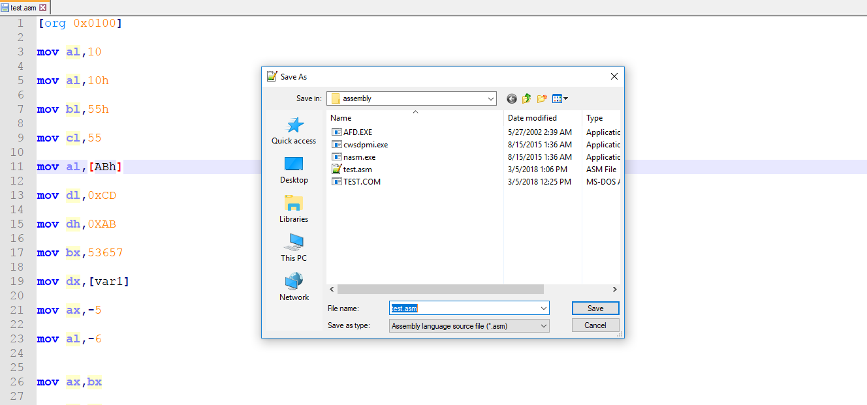

5) Now run Dosbox.

6) In dosbox window type **MOUNT C C:/assembly .** This will mount drive C and local directory C:/assembly will be formed.

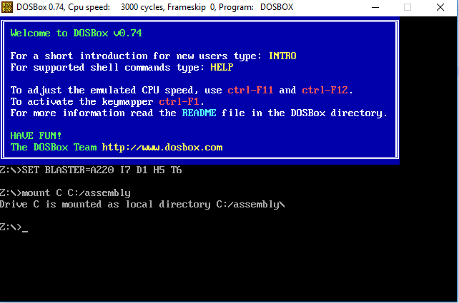

7) In dosbox window type **C:**

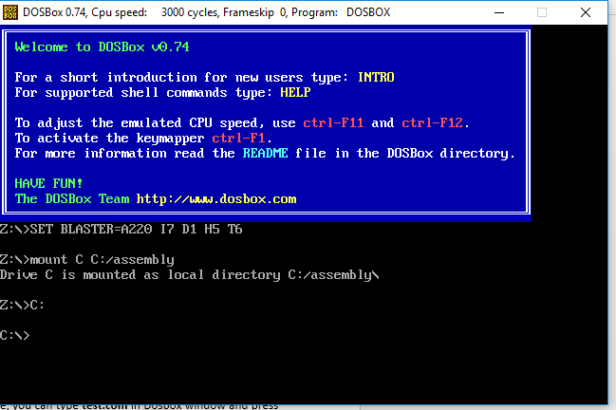

**For Assembler and Debugger usage:**

1)In dosbox window type **nasm test.asm -o test.com.** This will assemble the file test.asm and test.com will be created.

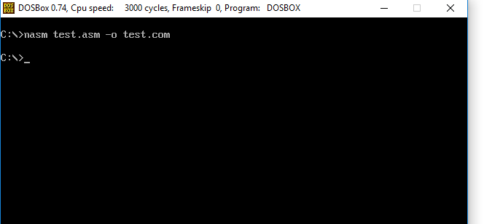

2) Finally type **afd test.com.** Debugger will open and you can test your code there.

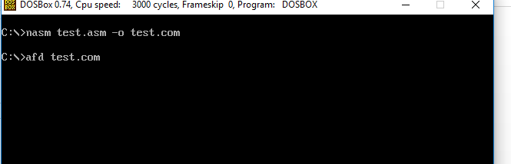

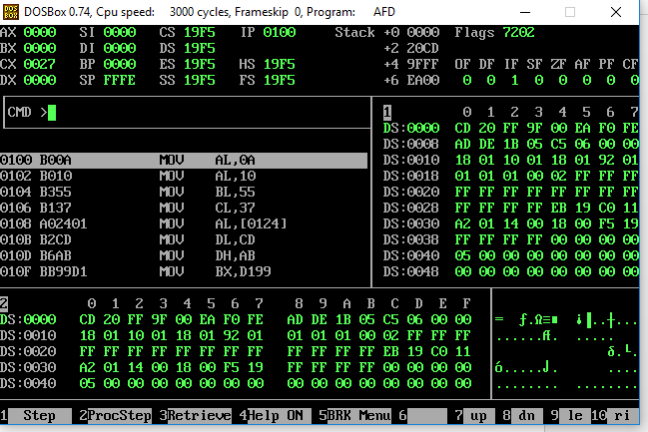

3. Strike **F1** to execute code step by step.

4. If you don’t want to debug and execute .com file, you can type **test.com** in Dosbox window and press enter.